Feasibility Study On India

*–Low Cost wins!*



**Rajan Verma**

23.03.2025

MAS WES 269 , HW-2

INTRODUCTION

Telecom costs are one of the lowest in the world. WIth razer thin margins lkot of consolidation has happened  in the Telecom sector in India in last 5 6 years. Actually India has seen many telecom players folding up their businesses. India allocates the spectrum and in India's case it has been the winner often times turns out to be the loser since they are never able to recover the spectrum costs. Anyhow the customer is the winner. There were 2 competitors Airtel and Reliance Jio but with wider options and integration of add on services I picked Out winer - Reliance Jioo _ Post paid Plan.

Key Points about Reliance Jio Services:

* 99.5 % percent population is covered.
* Over 80% of geographical area is covered.
* 2G Sunset Timeline: Jio doesn't support 2G,3G which could impact legacy devices
* Jio IoT Platform Features: Detailed capabilities of Jio's IoT management console
* API Integration Options: Available APIs for device management and data access
* Security Features: Encryption, access controls, and security compliance
* KYC Documentation Details: Specific documents required for enterprise IoT deployments
* TRAI Compliant
* Account Setup Time: Expected timeframe for enterprise account creation (2-3 weeks)
* SIM Procurement Lead Time: Time required from order to delivery (typically 1-2 weeks)

Analysis :

|  |  |  |
| --- | --- | --- |
| Parameter | Reliance Jio- Prepaid | Reliance Jio - Postpaid |
| Sim Cost | Free | Free |
| Activation Fees | Zero | Zero |
| 6 Month Plan | 4Usd (per month)X6=24 | 5Usd (per month)X6=30 |
| Limits on Data | Fair usage policy applies (e.g., 1.5 GB/day for basic plans). | 30 GB Data, thereafter Rs 10/GB |
| Total Cost for 1000 connections | USD 24000 | USD 30000 |

  Relinace Jio - Postpaid - the Winner due to higher data with marginally higher cost.

: 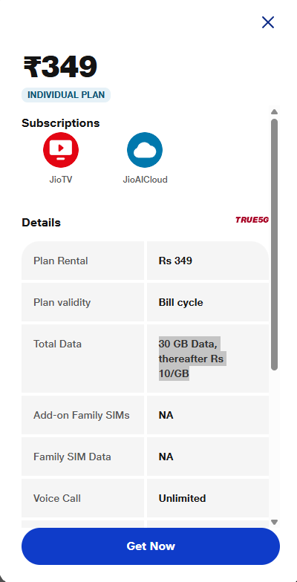

DATA for Indias Telecom Market:

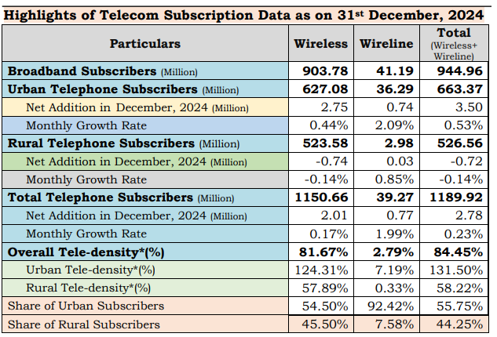

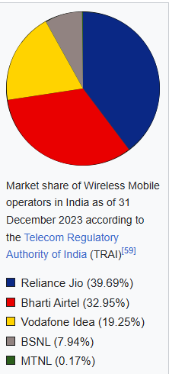

CONCLUSION

Reliance Jio - Post paid is chosen for a good balance of Services, Quality, features and data and roaming services.  Though there was  flip side that 2G and 3G was not coivered by  Jio so if the team works in cities Reliance Jio works if they want to travel to rural areas with 3G or 2G coverage we need to reconsider our decision.

REFERENCES

<https://www.trai.gov.in/sites/default/files/2025-03/PR_No.16of2025_0.pdf>

<https://en.wikipedia.org/wiki/Telecommunications_in_India>

<https://www.coai.com/home>

<https://economictimes.indiatimes.com/industry/telecom/telecom-policy/indian-telcos-have-enough-headroom-to-increase-tariffs/articleshow/106494604.cms?from=mdr>

https://www.jio.com/selfcare/plans/mobility/postpaid-plans-home/

Feasibility Study On UK

*–Low Cost wins!*



**Rajan Verma**

23.03.2025

MAS WES 269 , HW-2

INTRODUCTION

The UK telecommunications market is a mature and highly consolidated landscape dominated by four major Mobile Network Operators (MNOs): BT/EE, Vodafone, O2, and Three, complemented by numerous Mobile Virtual Network Operators (MVNOs). Valued at approximately £39 billion annually, the sector faces intense price competition and declining traditional revenue streams, offset by data growth. With 92% smartphone penetration, UK consumers prioritize network reliability, value for money, and data allowance, showing a trend towards 24-month contracts and digital-first engagement. Regulatory oversight by Ofcom ensures consumer protection and open market principles, while technological advancements like 5G, IoT growth, and network virtualization drive market dynamics. The market faces challenges in rural coverage. Compared to India this telecom market is not cheap at all! When I researched cost differences were huge and thats why I went with a cheaper provider taht is GifdfGaff which is MNO but I save alsmose half the money over Vodafone. So before we jump into the winner details and comparison here is history of UK telecom sector and providers.

History of UK Telecom Providers:

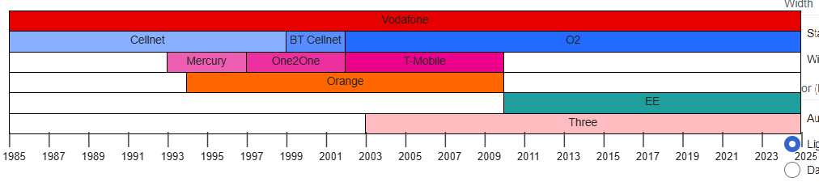

Comparison between 2 choices:

|  |  |  |
| --- | --- | --- |
| Parameter | GiffGaff | Vodafone |
| Sim Cost | Free | Free |
| Activation Fees | Zero | Zero |
| 6 Month Plan | 62.2 | 156 |
| Limits on Data | 20GB per month | 1Gb daily then , throttled at 2Mbps |
| Total Cost for 1000 connections | 62200 | 1,56000 |

GiffGaff (operating on O2 network)- the Winner due to cheaper cost and great coverage.

Key Points:

* 99% percent population is covered.
* Over 70% of geographical area is covered.
* 2G Sunset Timeline: 2033
* 3G Sunset Timeline : 2025
* IoT Platform Features:  Not Supported.
* API Integration Options: Not Supported
* Security Features: emphasizes account security with features like two-step verification, strong password requirements, and fraud prevention measures. However, it lacks enterprise-grade security features like encryption for IoT data
* Account Setup Time: 1-2 Days
* SIM Procurement Lead Time: 1-2 Days

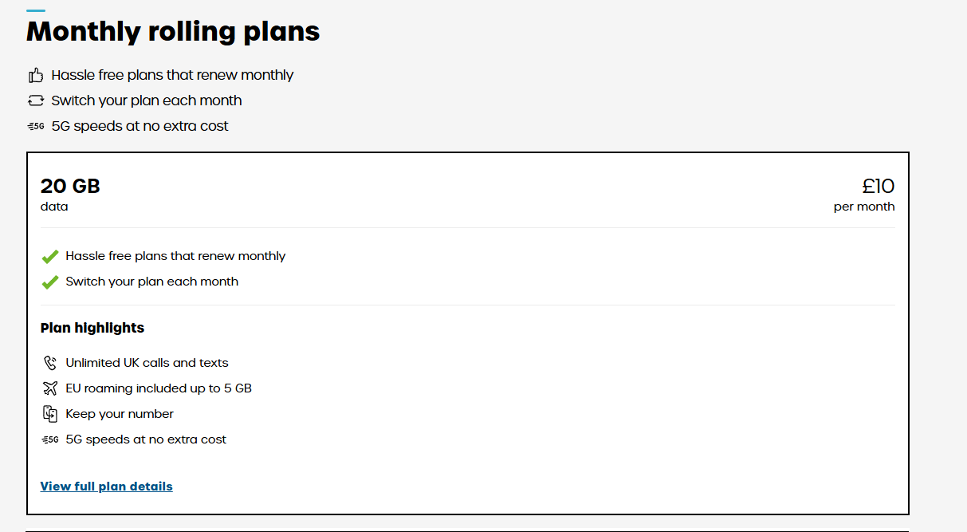

CONCLUSION

Giffgaff stands out as a winner in the UK telecom market due to its unique customer-centric approach and flexible offerings. As an MVNO operating on the O2 network, Giffgaff provides excellent coverage and competitive pricing without long-term contracts, appealing to cost-conscious consumers. Giffgaff's flexible, no-commitment plans and data bundles cater to diverse needs is icing on the top for the prices. This combination of affordability, flexibility, and community engagement makes Giffgaff a popular choice among UK consumers

REFERENCES

<https://wavetelbusiness.co.uk/latest-news/top-10-teleccommunication-companies-in-united-kingdom-uk/>

<https://www.giffgaff.com/sim-only-deals>

<https://en.wikipedia.org/wiki/Telecommunications_in_the_United_Kingdom>

https://www.vodafone.co.uk/sim-only/best-sim-only-deals